**DWS Product Installation Guide**

**1.Purpose -**

Purpose of this document content steps to install software Armstrong DWS software on server PC.

## 2.Pre-requisites

1. All hardware should be in same network PC,Weighing ,VMS,PLC,Scanner are should be in same Network
2. Server PC configuration should be as below.
3. Internet Connectivity should be there.
4. Server PC should have USB and Ethernet port.
5. Server PC Should be within 1 meter range from PLC.

**3.Pre-installation Task.**

3.1 Connect Ethernet Cable to Server PC.

3.2 Connect Hand Scanner USB Cable to Server PC.

3.3 Get the PLC,Weighing,VMS IP from automation Engg.

**3.4 Check PLC And PC In Same network or not**

Follow the folowing steps to check plc and PC communication

1.In start Type **CMD** Then Click On **Command Prompt**

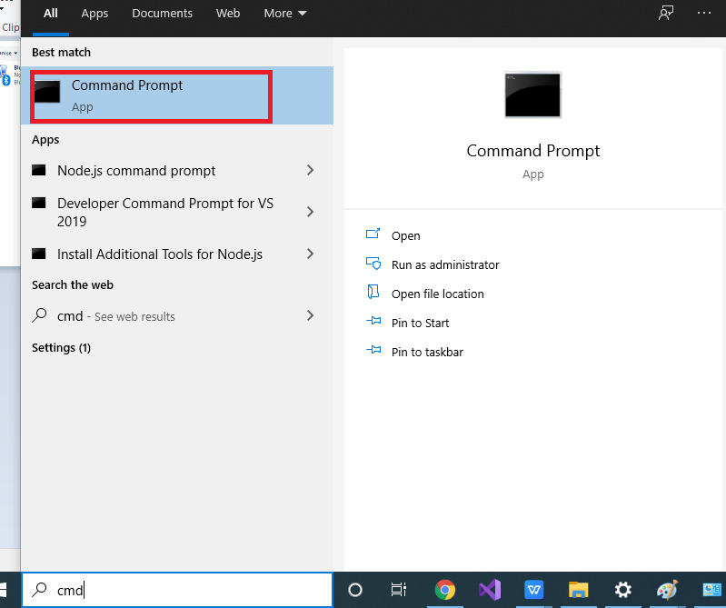

**2.Type PLC IP** in For Ex:- PLC IP is 192.168.1.1 then type ping 192.168.1.1 -t

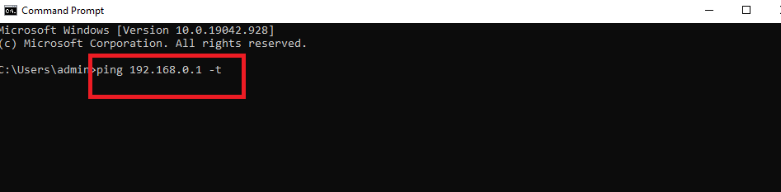

If **PLC and PC** is not in same network then it Shows

Failure of timeout

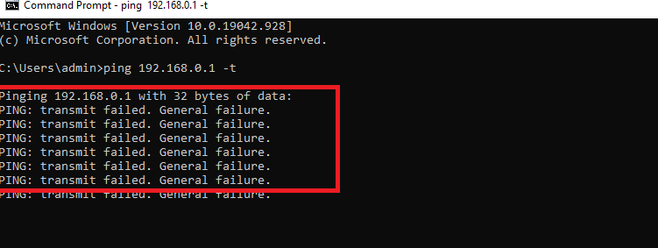

If Connected will get response

**IF PLC and Server PC is not connected in same network then configure Server PC IP.**

**Follow the following steps to configure IP address**

* **Configure PC IP** -

Right Bottom On Internet Icon Right Click And Click on Open **Network And internet Setting**

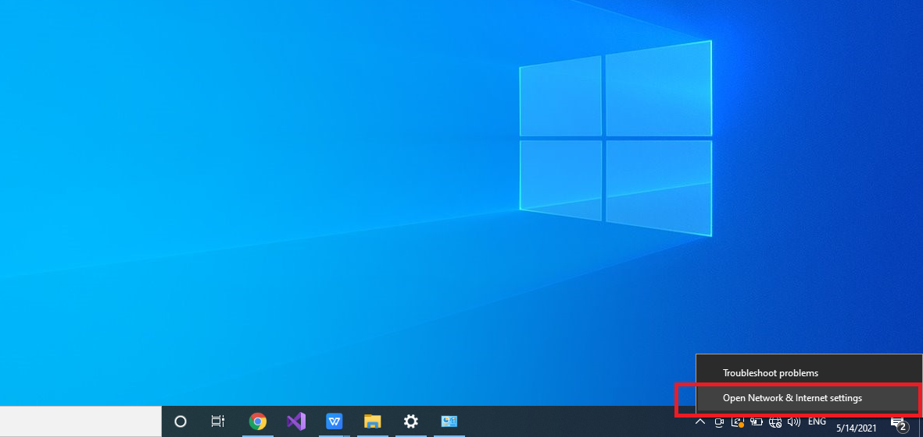

Click on **Ethernet**

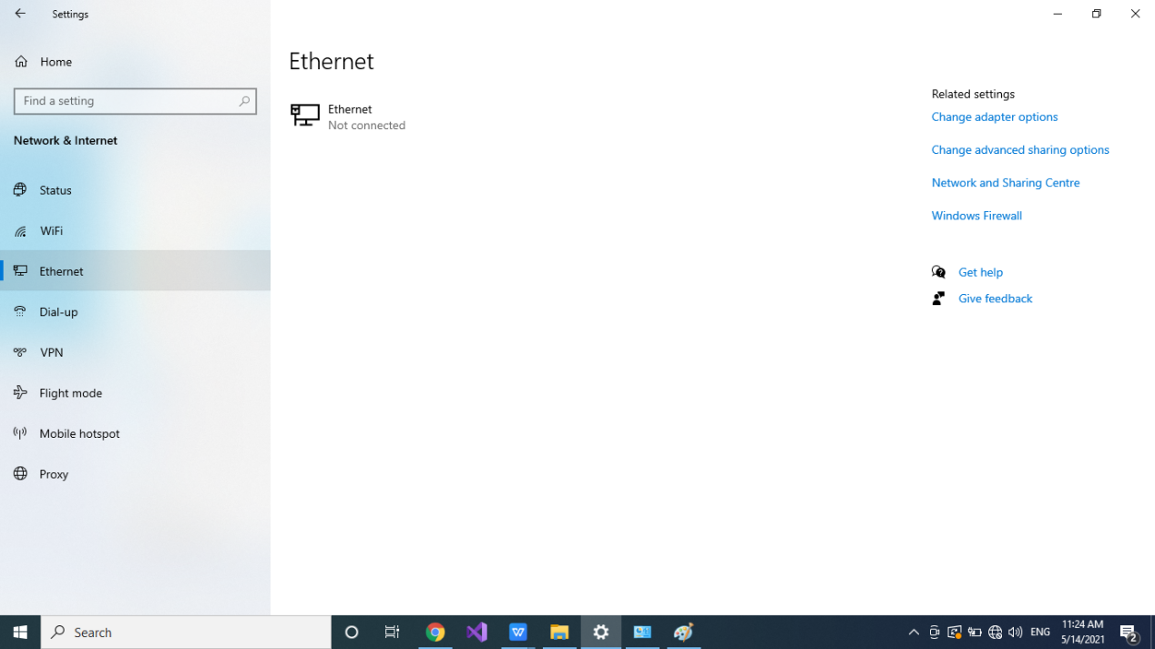

Then Right Top Corner **Change adapter Option** Click on

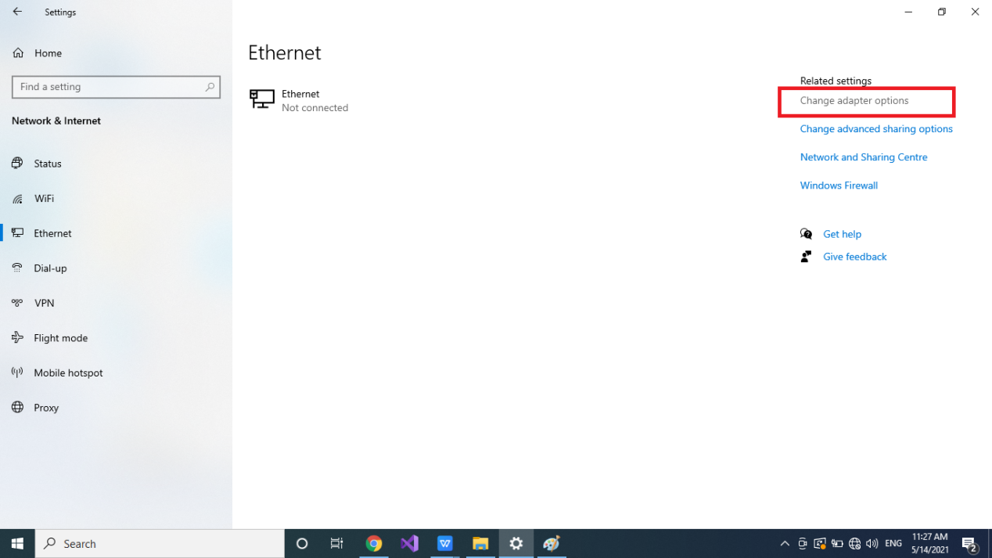

Click on **Ethernet** (if LAN Connected then Red Cross will not show it Will Show Green Tick)

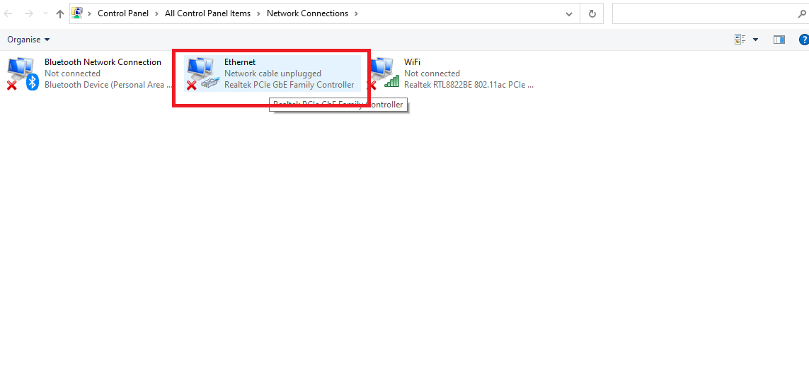

**Right Click on Ethernet And Click on Properties**

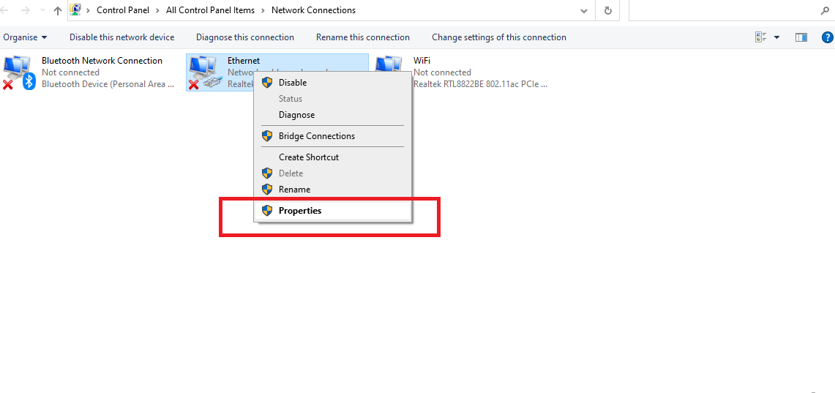

Click on **Internet Protocol Version 4(TCP/IPV4)** and click on Properties

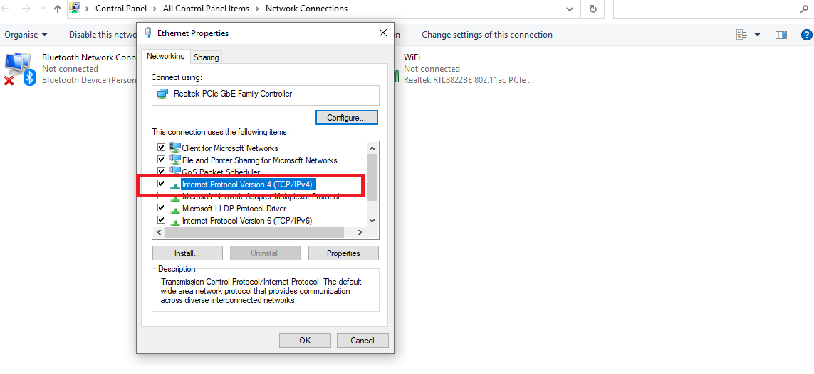

Click on **Use the following Address as shown in image below**

**IP Address: 192.168.1.60** (In range of PLC IP Between 0 to 255 except PLC IP)

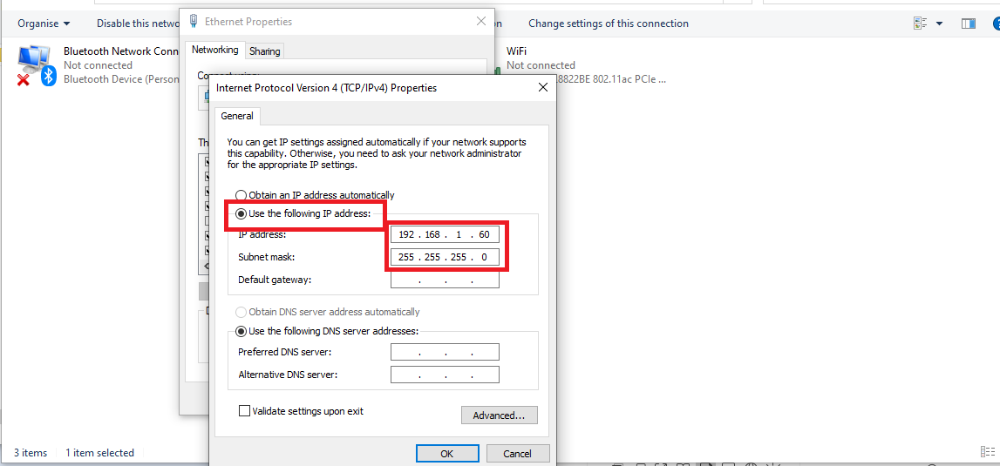

Click on **OK**

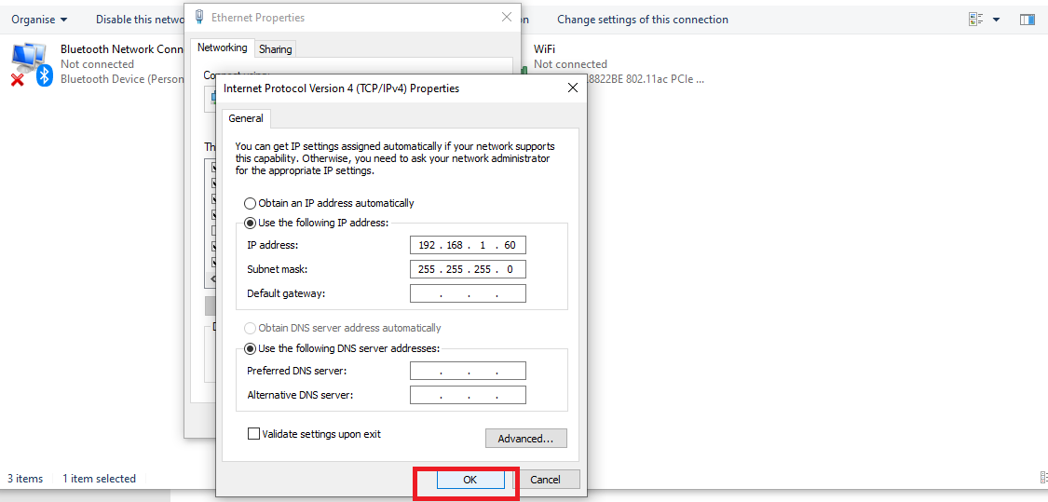

Click On Close

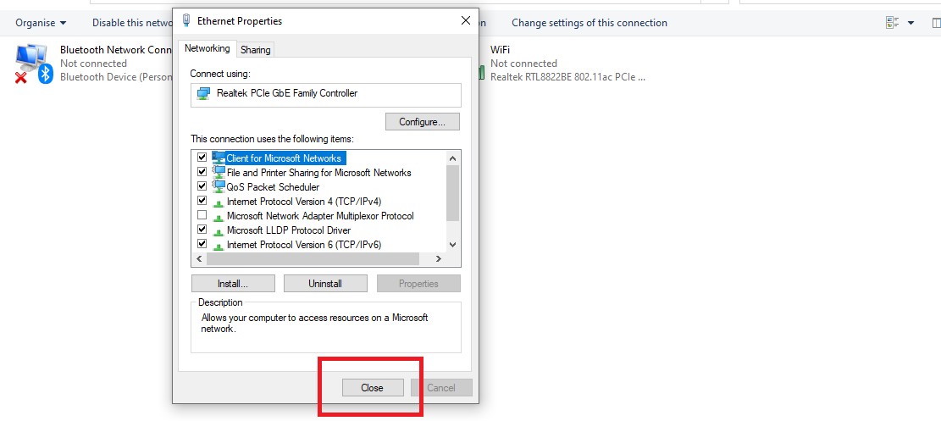

**4.Turn Off Firewall security on PC**

To access PC In Network

1. In Start Type Firewall Click on **Firewall & Network Protection**

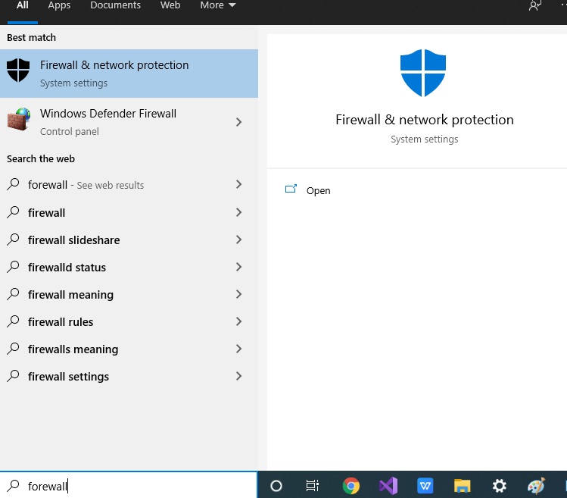

1. Click on **Domain Network**

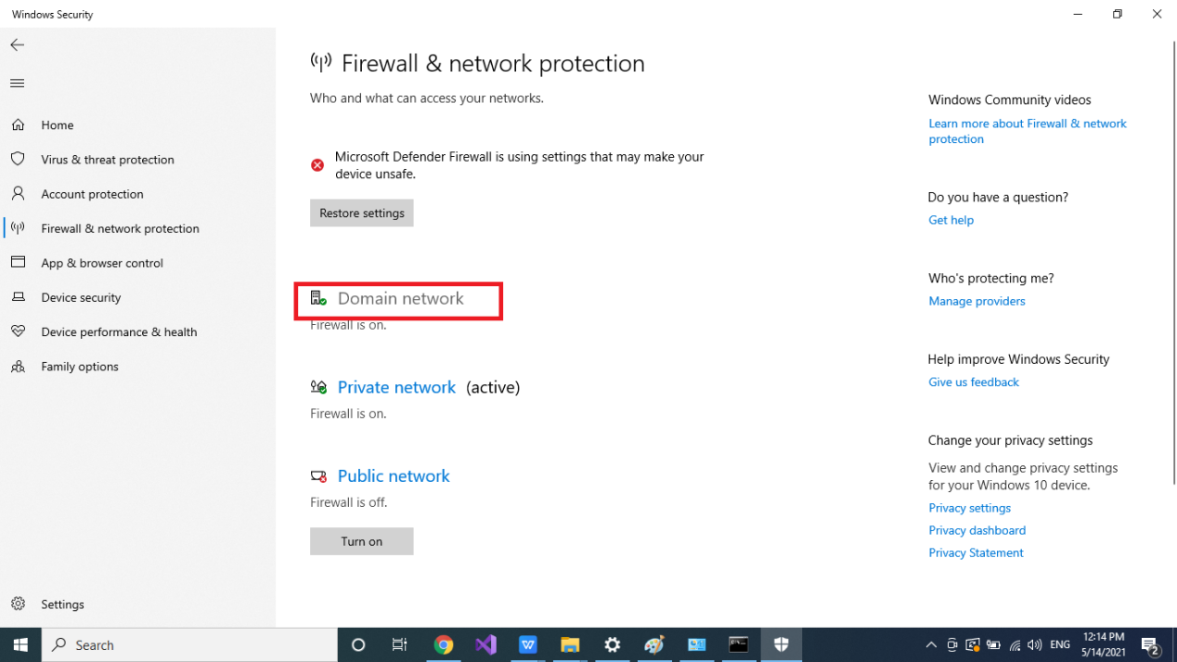

Click on **Firewall off**

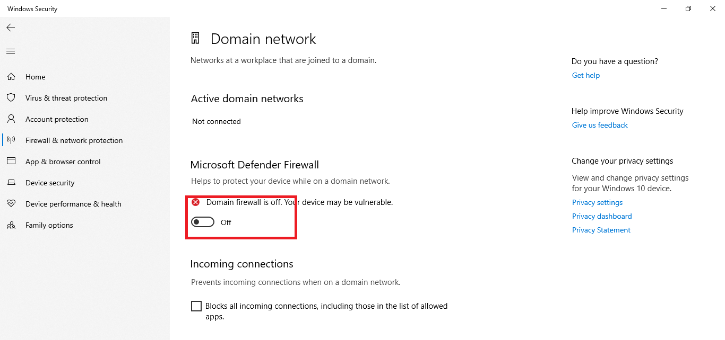

Back to **Firewall & Network Protection**

Click on **Private Network**

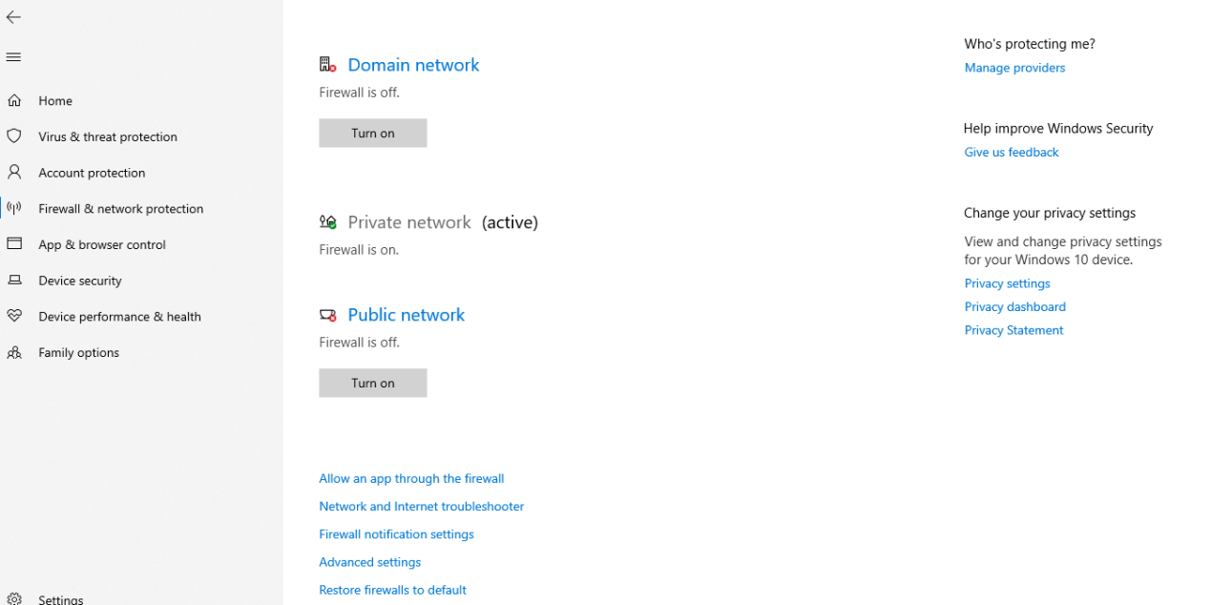

**Turn Off Firewall**

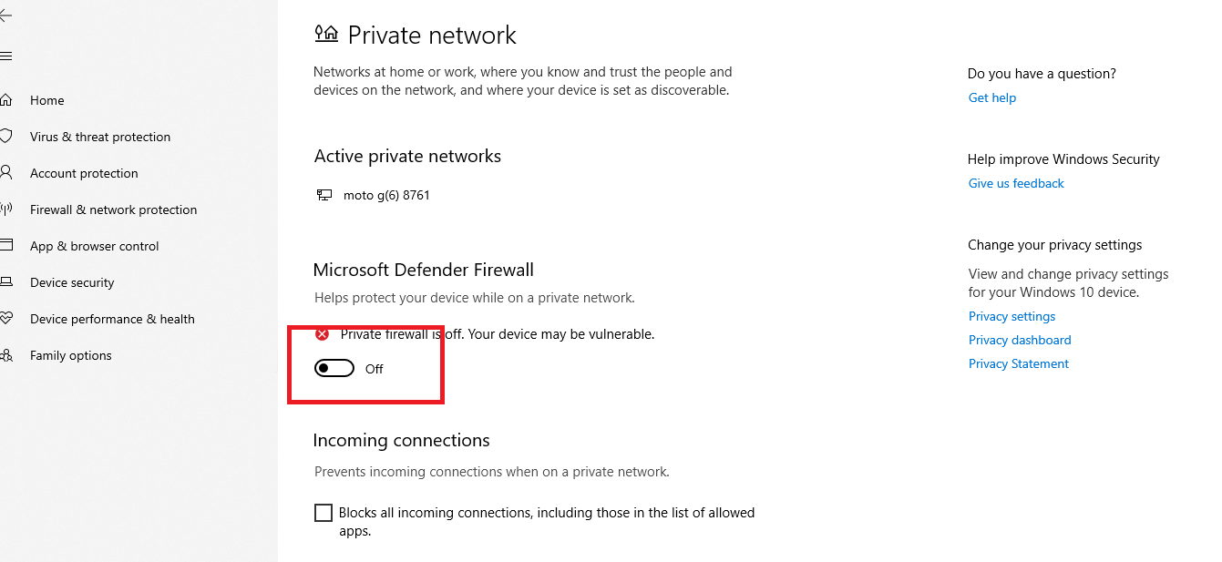

Back To **Firewall & Network Protection**

Click on **Public network**

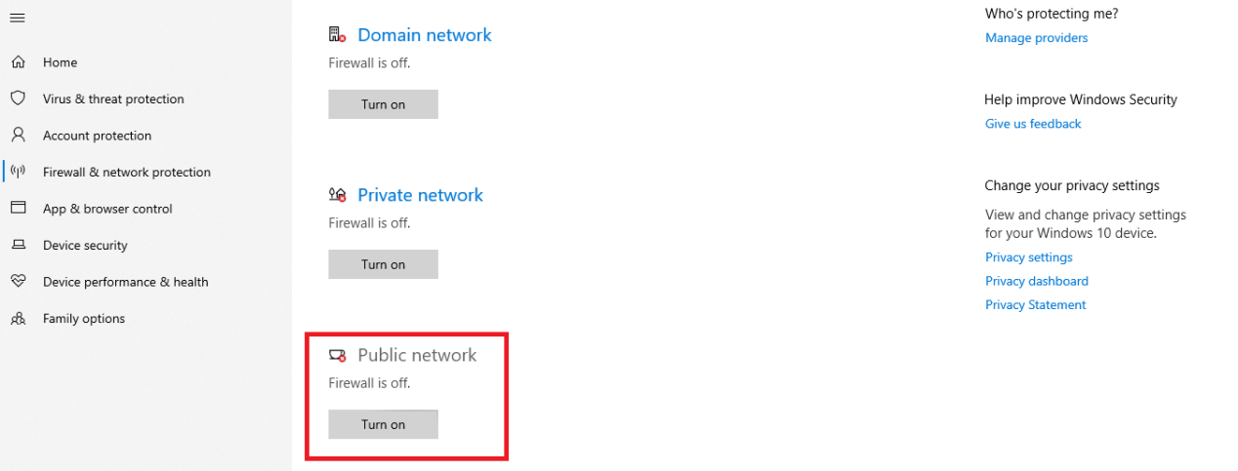

**Turn off Firewall**

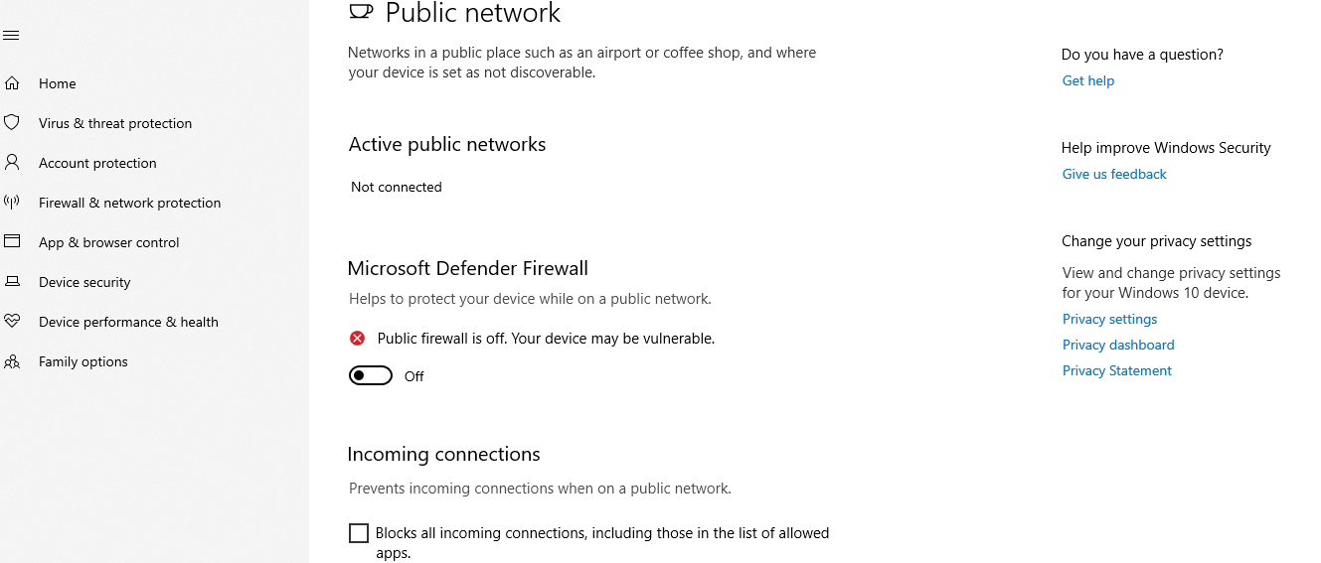

**Close.**

1. **Software Deployment in PC/Computer**

**To deploy the application on the server pc follow the following steps**

1. Create AMBPL_DWS folder in any Local Drive.
2. Copy AMBPL_Camera_Preview folder into AMBPL_DWS
3. Copy AMBPL_Data_Handshake folder into AMBPL_DWS
4. Copy AMBPL_Weighing_Application into AMBPL_DWS
5. Copy AMBPL_Publish folder into AMBPL_DWS
6. Configure App.config file.
7. Publish Web application in IIS
8. If IIS is not configured the to configured IIS Follow following steps.
9. SQL Server is not installed then follow the steps to install & download SQL server

Before the deployment of the web application we need to check whether the IIS is configured on server PC or not .

If not configured then need to configure.To check IIS configured or not please refer below steps

Type IIS in search panel if it is visible in menu List then no need to configure it is already configured.

But if IIS is not appeared in search list then follow the following steps to configure IIS.

To Configure IIS refer the following steps.

1. Go to **Control Panel** > **Programs and Features** > **Turn Windows features on or off**.

# Enable and Set Up IIS

1. Type in Start Control Panel then Click On control Panel

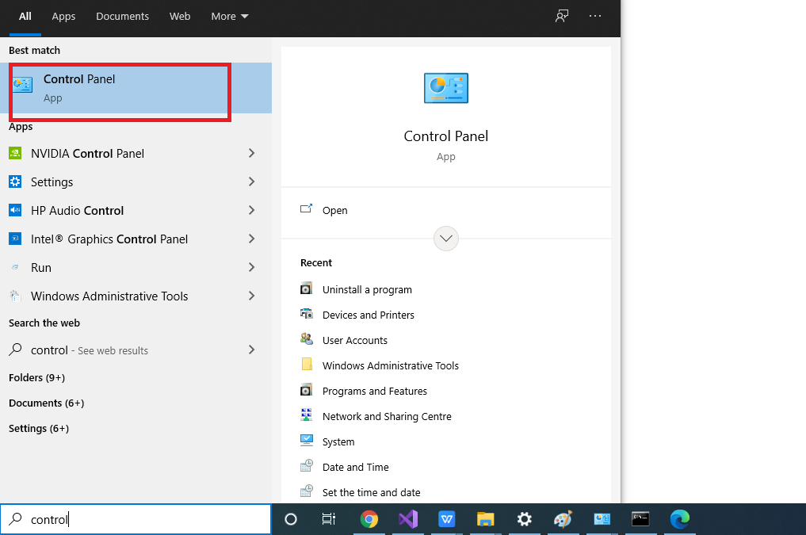

1. Then Click ON **Programs**

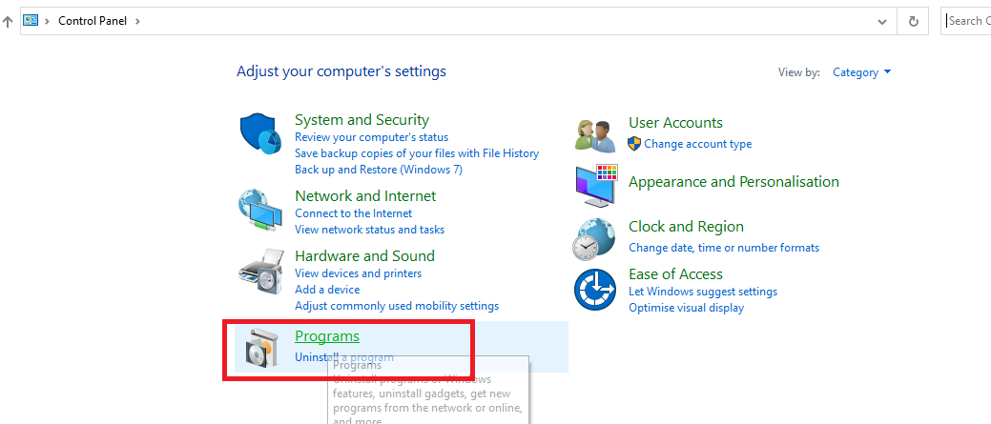

1. Click on **Turn Windows Features on or off**

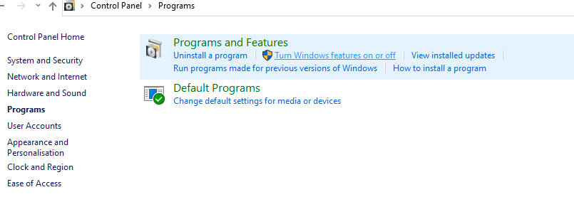

Under **Internet Information Services**, turn on the following:

* **Web Management Tools**: IIS Management Console
* **World Wide Web Services**
  + **Application Development Features**: ASP.NET 3.5 and 4.6
  + **Common HTTP Features**: Default Document and Static Content
  + (Optional) **Security**: Basic Authentication
* **Internet Information Services Hostable Web**
* **Core**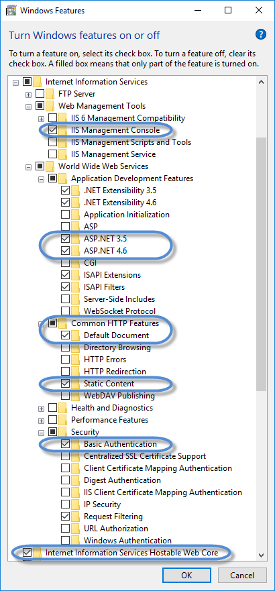

You can create a new website or set up an existing one for use with DNN. Choose one of the next two steps.

1. To create a new website and point it to the DNN installation folder:
   1. Go to **Control Panel** > **Administrative Tools** > **Internet Information Services (IIS) Manager**.
   2. In the **Connections** panel, expand your host tree, right-click on **Sites**, and choose **Add Website**.

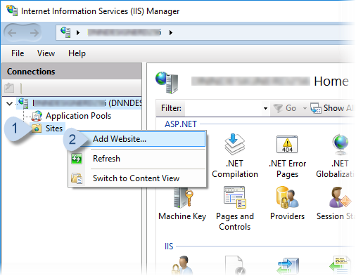

Enter the new website's name and choose the location

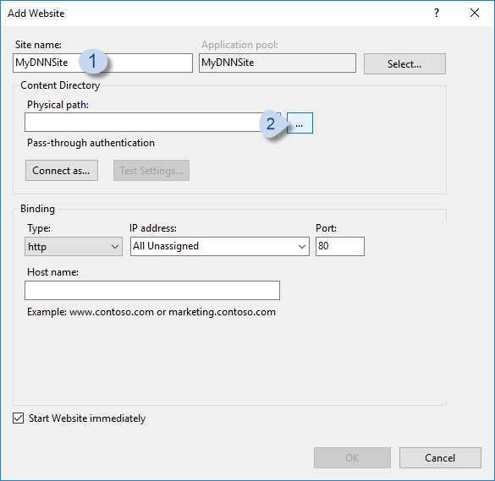

Enter the **Host name**.

Developers and Designers: If setting up a local development environment, you can use  (or any subdomain). DNNDEV.ME is a registered domain which points to the loopback address of 192.168.0.51 so it will always resolve locally.

Administrators: If setting up a live website, use your website's domain.

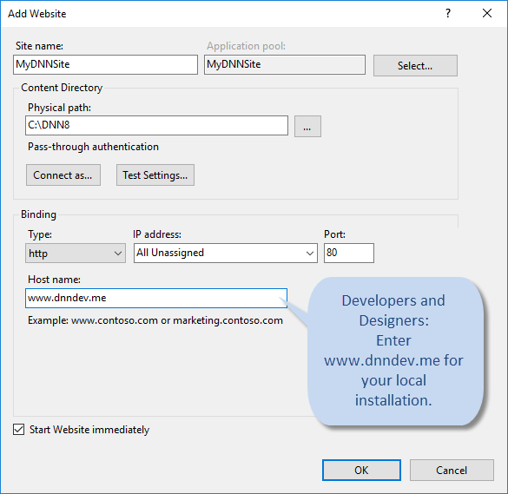

To use an existing IIS website:

1. In the **Connections** panel, right-click on the name of the existing website, and choose **Edit Bindings...**.

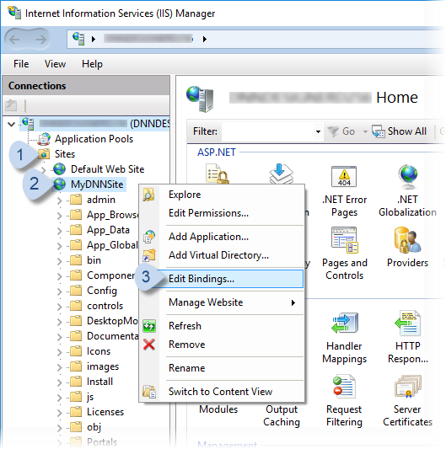

In **Site Bindings**, click/tap **Add...**. In **Add Site Binding**, enter the **Host name**.

Developers and Designers: If setting up a local development environment, you can use  registered domain which points to the loopback address of 192.168.0.51, so it will always resolve locally.

Administrators: If setting up a live website, use your website's domain.

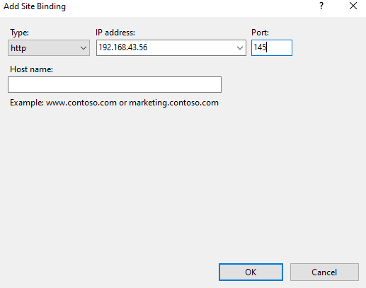

To Open website open Sites Right Click on Sites Manage Website >> click on Browse

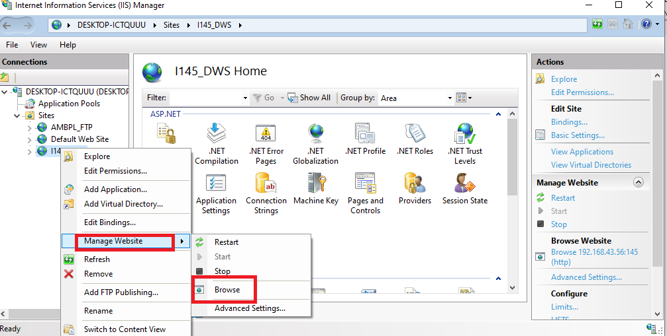

Then It Directly open in Browser

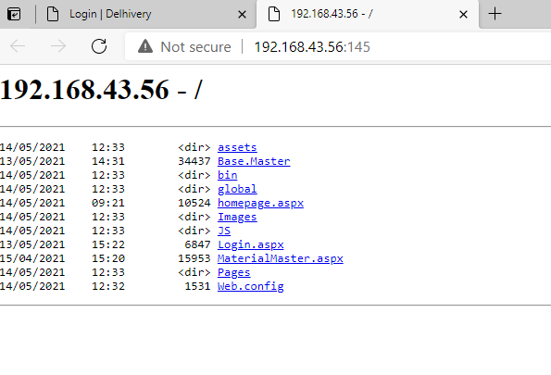

Now Click on Login.aspx Page Website Will Reflect/Open

6.Data Handshake Service Windows Service Installation

1. Open .exe file of service to contagiously update data from System.

For Install Service

cd C:\Windows\Microsoft.NET\Framework\v4.0.30319

installutil.exe "C:\Services\myservice.exe"

For Uninstall Service

C:\Windows\Microsoft.NET\Framework\v4.0.30319\installutil.exe -u "C:\Services\myservice.exe"

6.Install SQL EXPRESS

## Download SQL Server Express edition

We can download the express edition of SQL Server 2019 from the [Microsoft official web site](https://www.microsoft.com/en-us/sql-server/sql-server-downloads" \t "https://www.sqlshack.com/how-to-install-sql-server-express-edition/_blank). On this download page, we can find out the express edition download link. When we click the **Download now** link, we can begin the download process:

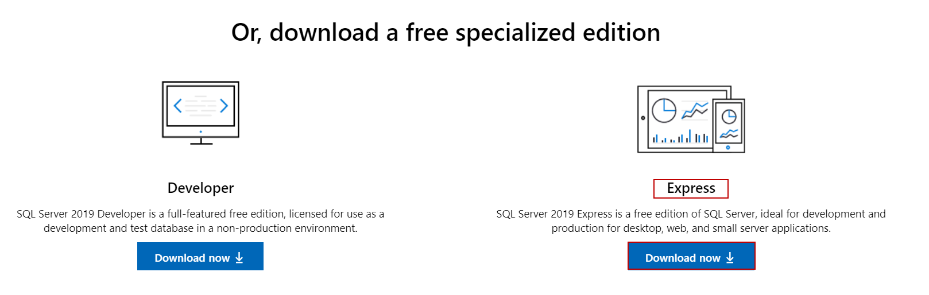

After downloading the setup package, we can start the installation steps. We will right-click the installation file which is named **SQL2019-SSEI-Expr.exe**and select the **Open**option in order to start the installation process. In this step, we must make sure that the logged-on user already has the necessary rights to install the programs on the computer. Otherwise, we can face problems during the installation steps:

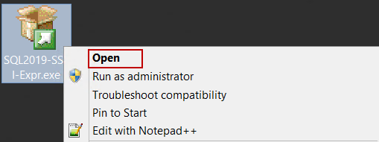

After starting the installation, we have to choose the installation type of the SQL Express edition:

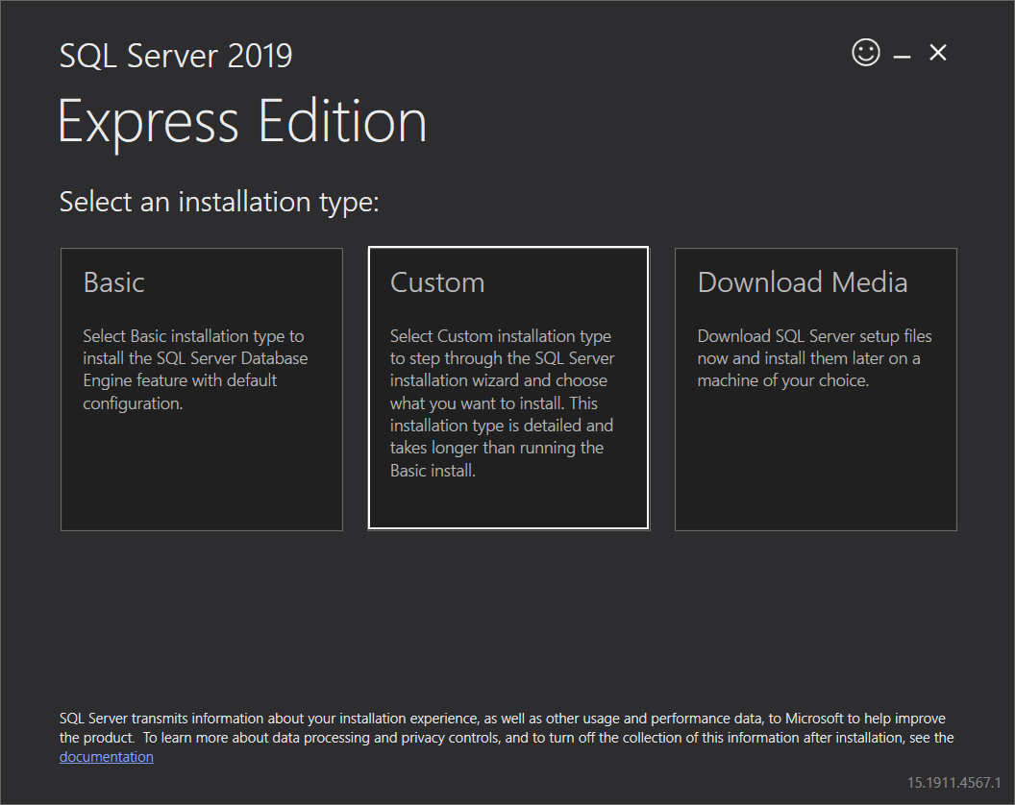

The**Basic**installation method is the quickest and easiest installation method to install the SQL Server Database Engine with the default configuration.

The **Download Media** option also allows us to download the setup files for offline installations

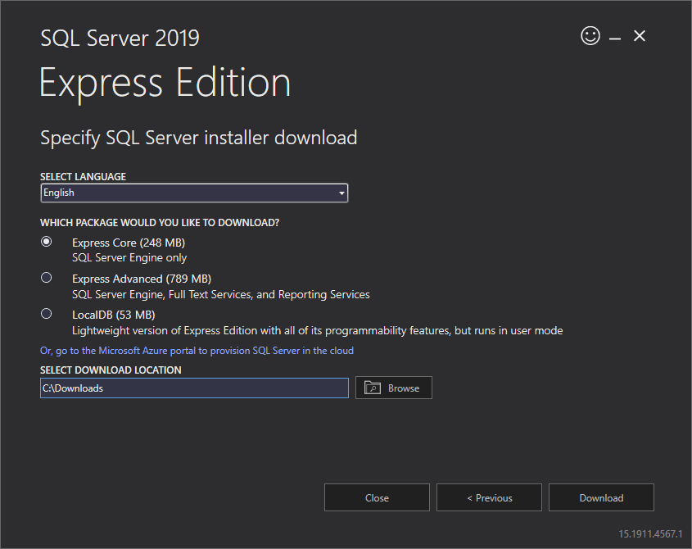

The**Custom**installation method offers more advanced installation options so that we can configure the features and other options of the SQL Server installation. We will use the **Custom** installation method. In the next screen, we will set the path of the setup files to be downloaded and then click the **Install** button

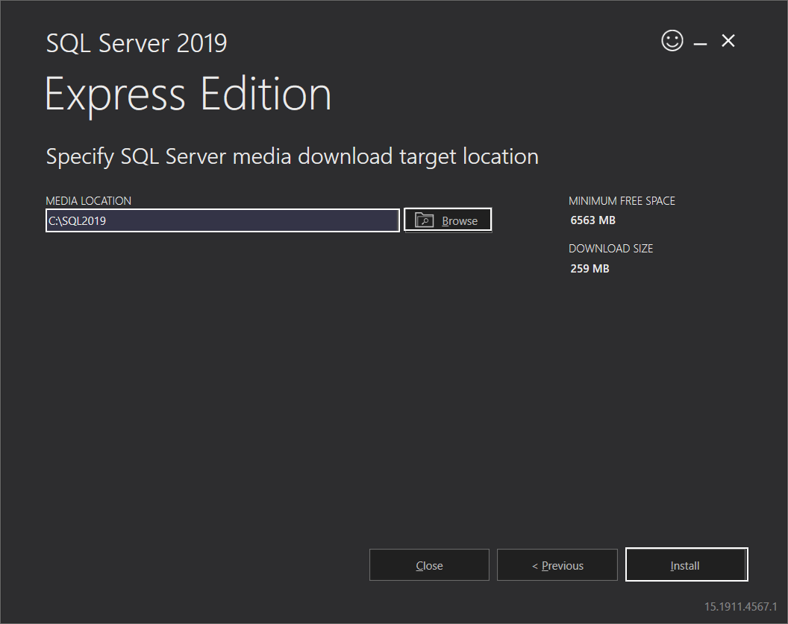

The downloading process will be started and the elapsed time for this operation can be varying according to your internet connection speed:

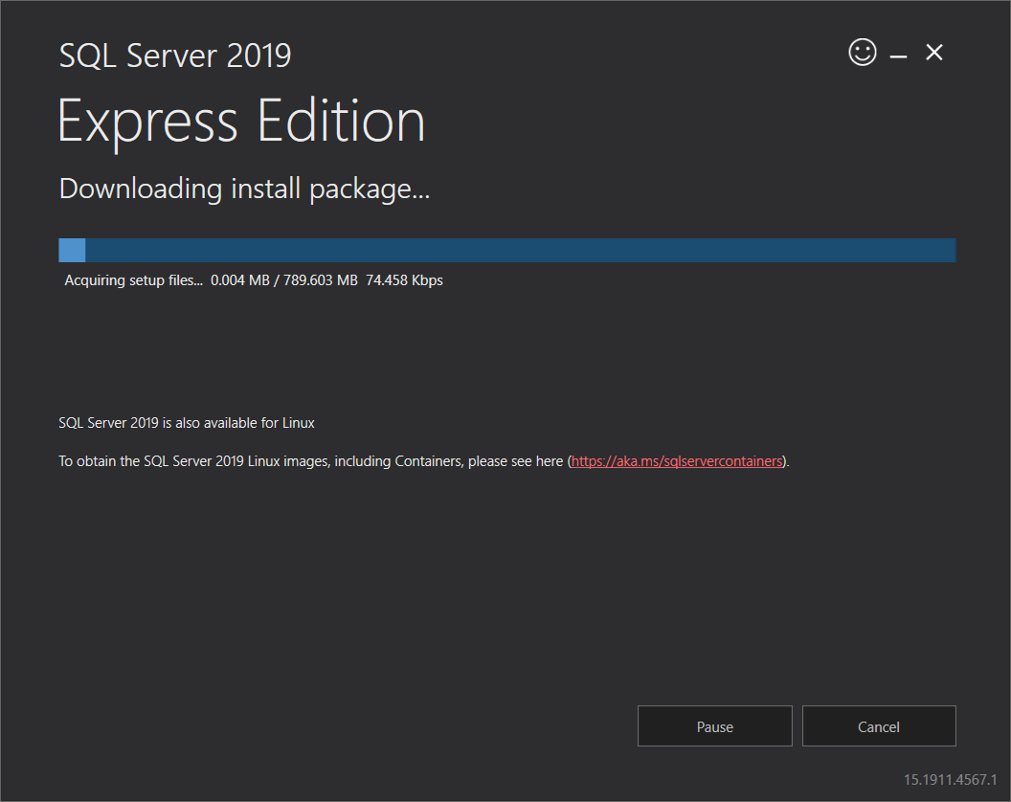

## Installing SQL Server Express edition

After the completion of the download, the **SQL Server Installation Center** will meet us. In this screen, besides installing the SQL instance, we are able to install SQL Server Reporting Service, SQL Server Management Studio or SQL Server Data Tools and we can also upgrade the installed version of SQL Server.

Now, we will select the **New SQL Server stand-alone installation or add features to an existing installation**option to start the installation

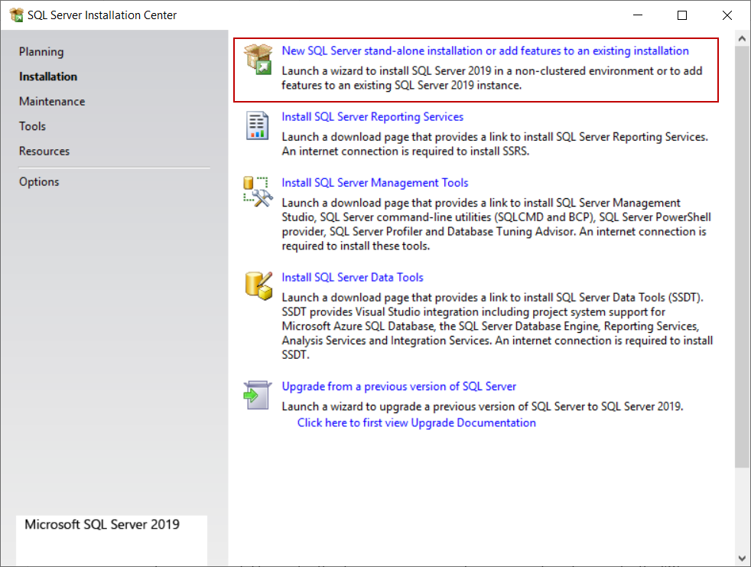

We will accept the license terms and other details on the **Licence Terms** screen and click **Next**:

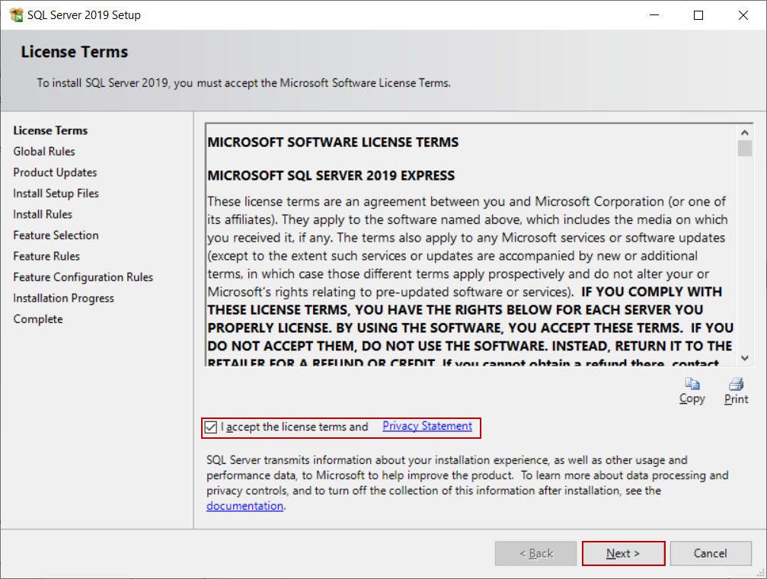

The **Global Rules** screen will be launched and, the SQL Server Setup will be checked the computer configurations:

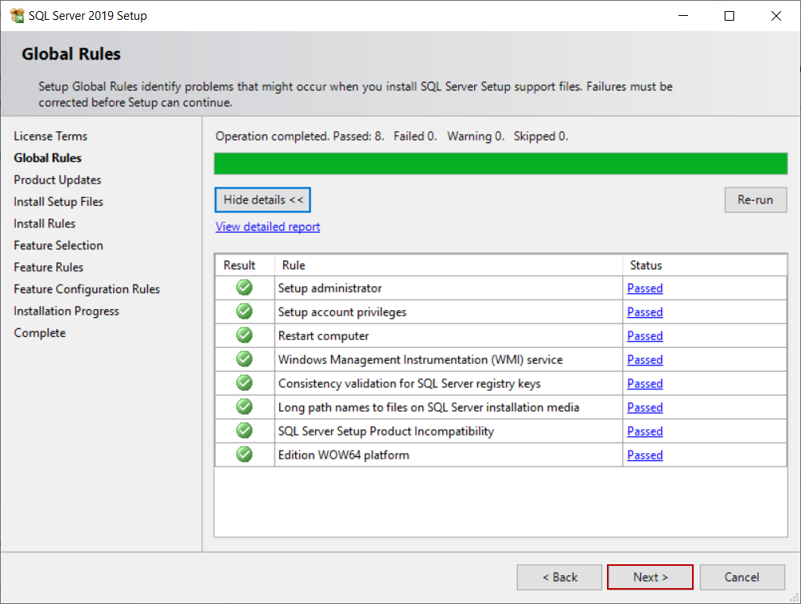

The **Product Update** screen checks the latest updates of the SQL Server Setup and if we don’t have an internet connection, we can disable the **Include SQL Server product updates**option:

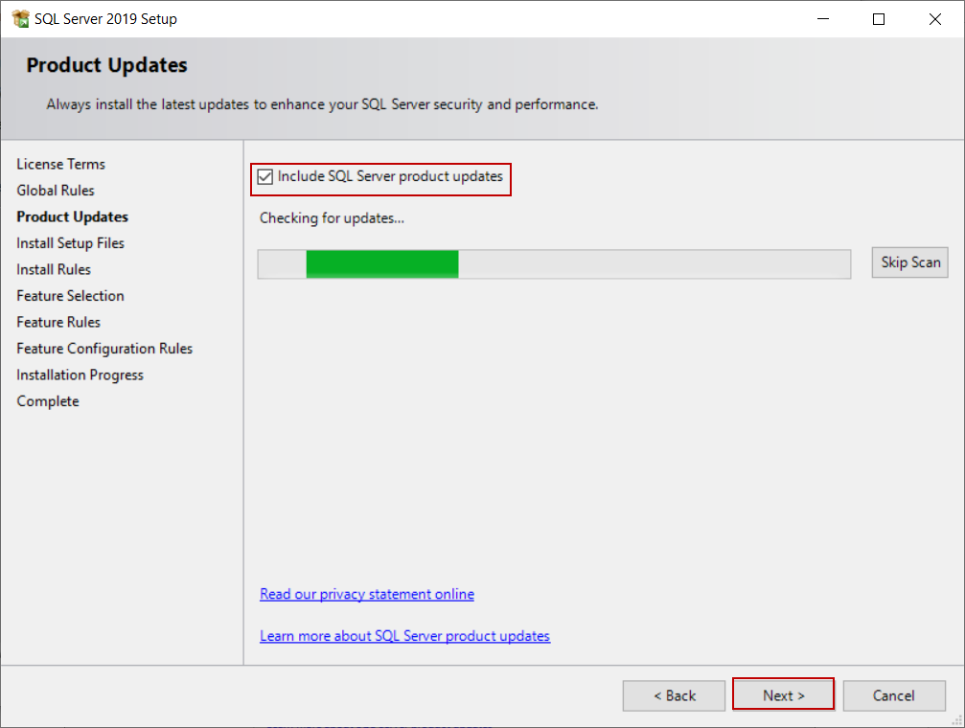

In the **Install Rules** screen, the potential issues will be checked by SQL Setup that might be occurred during the installation. We will click the **Next** button and skip the next step

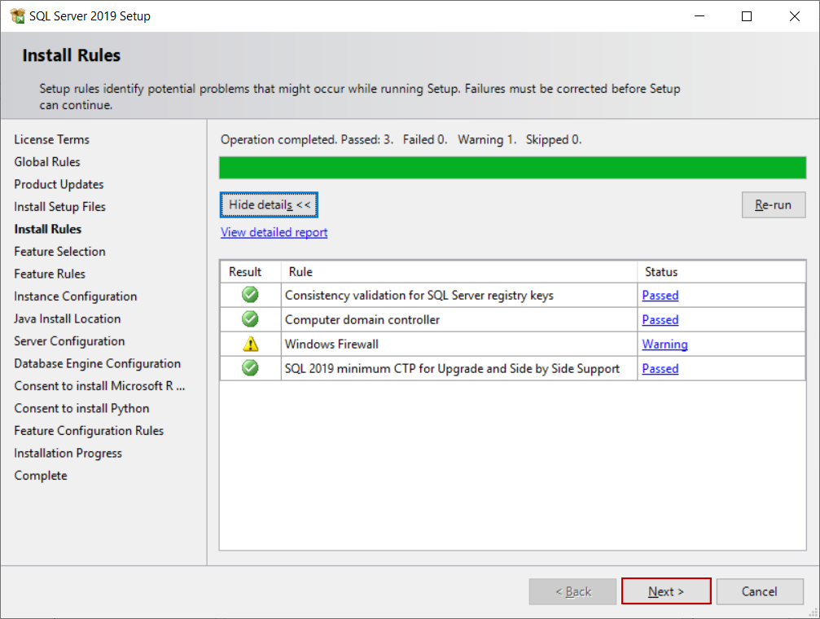

In the **Feature Selection** screen, we can select the features which we want to install. For this installation, we will disable the following features:

* Machine Learning Services and Language Extensions
* Full-Text and Semantic Extractions For Search
* PolyBase Query Service for External Data
* LocalDB

At the same time, we can specify the installation path of the SQL Server through the**Instance root directory** option

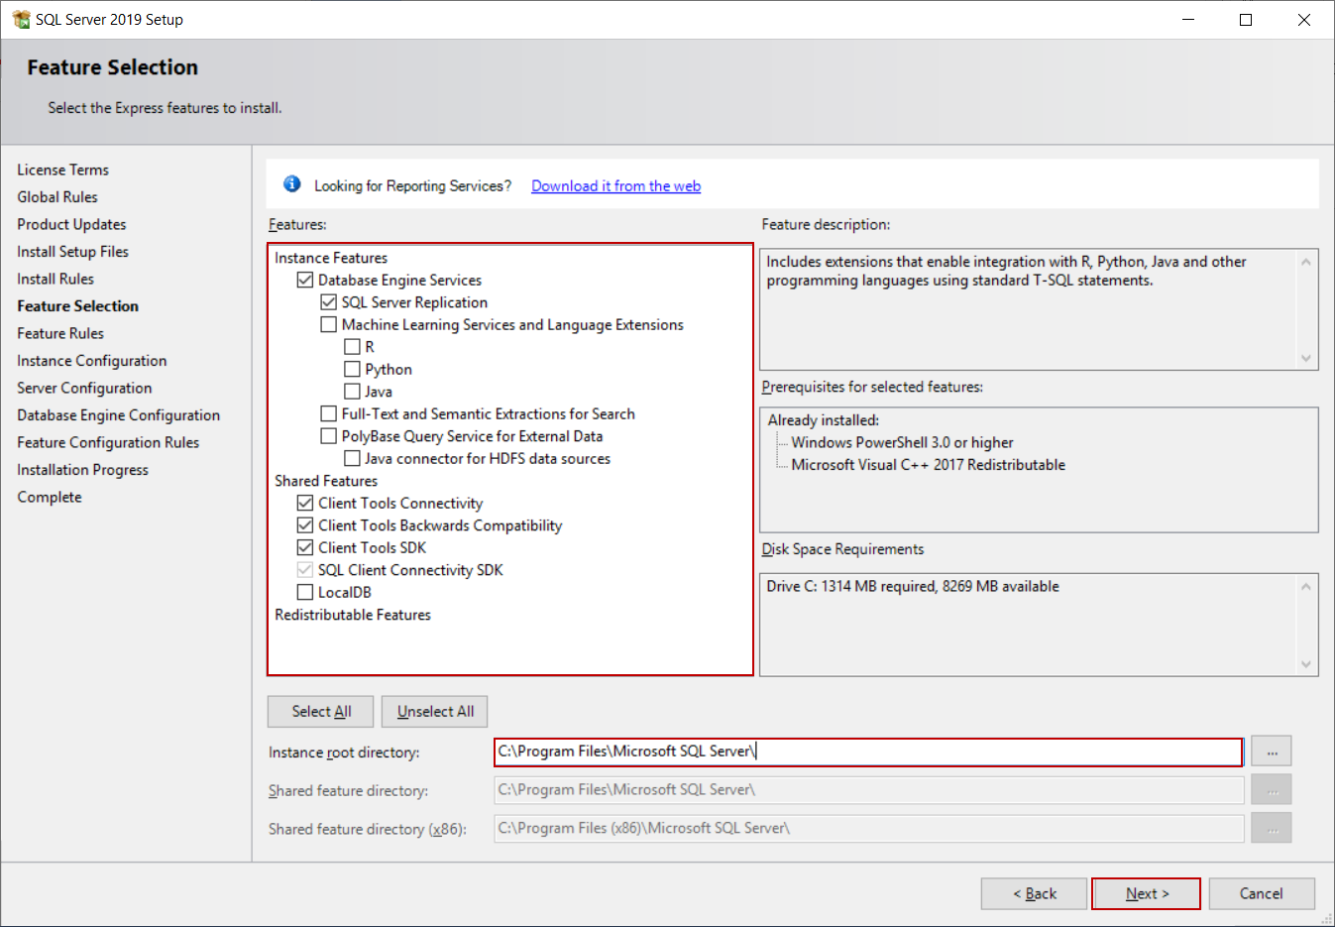

In the **Instance Configuration** screen, we will give a name to the SQL instance but we will not change the default name of the installation. Click the **Next** button

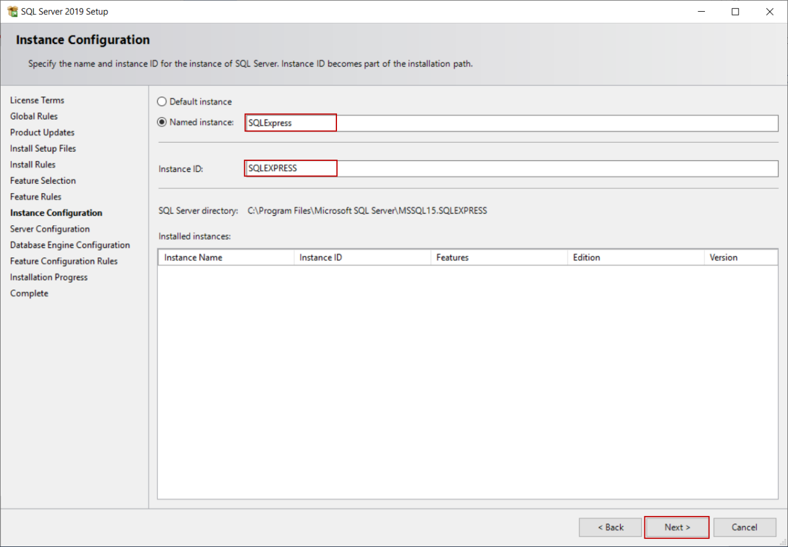

In the **Server Configuration** screen, we can determine the startup type of the SQL Server Database Engine and SQL Server Browser services. We will not change the default options

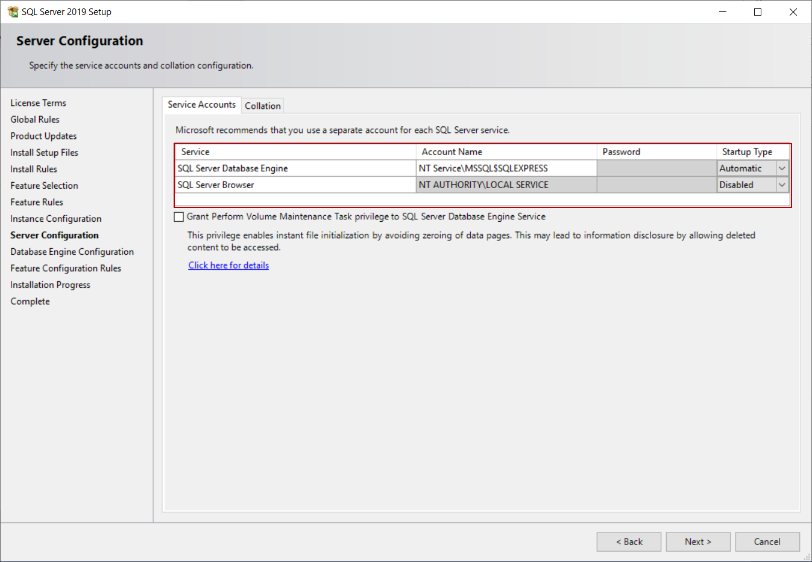

At the same time, we can determine the service account of the SQL Server Database Engine and SQL Server Browser. In the **Collation** tab, we can customize the Server collation option of the SQL Server

In the **Database Engine Configuration** screen, we will specify the authentication mode of the SQL Server. We have two options on this screen.

In the **Windows authentication**mode, the SQL logins are controlled by the Windows operating systems and it is best practice to use this mode.

In the **Mixed Mode**, the SQL Server can be accessed with both Windows authentication and SQL Server authentication. For this installation, we will select the Mixed Mode option, so we will set the password of the sa login of the SQL Server and we will also add a windows login. We can directly add the current windows user to the windows through the **Add Current User** button:

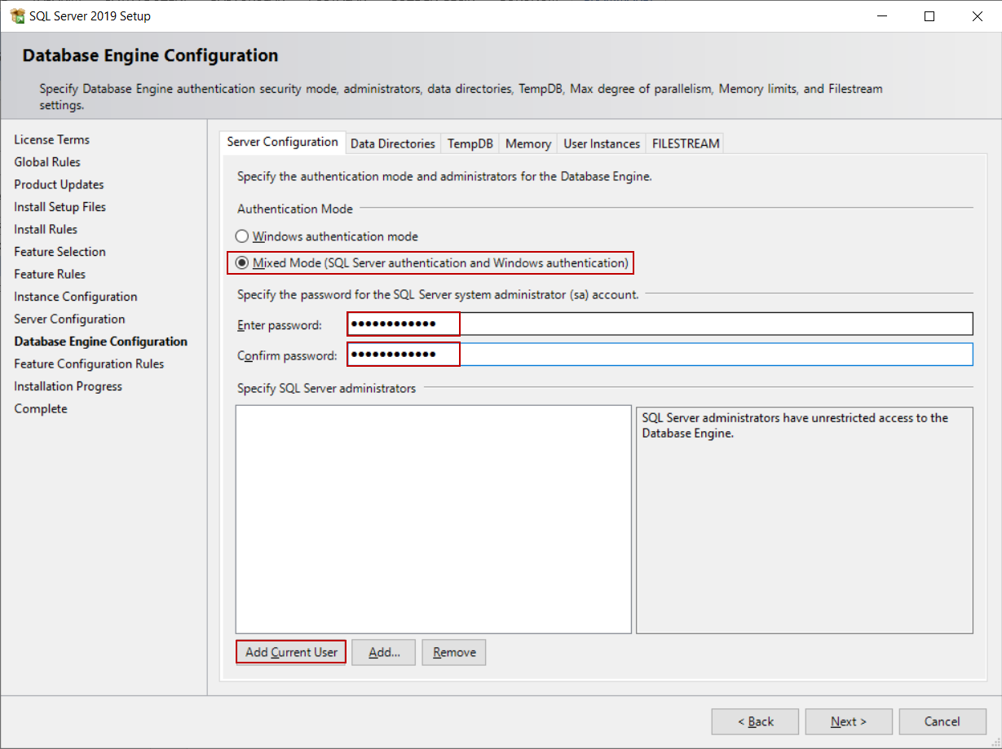

In the **Data Directories** tab, we can set the default directory of the database and backup files

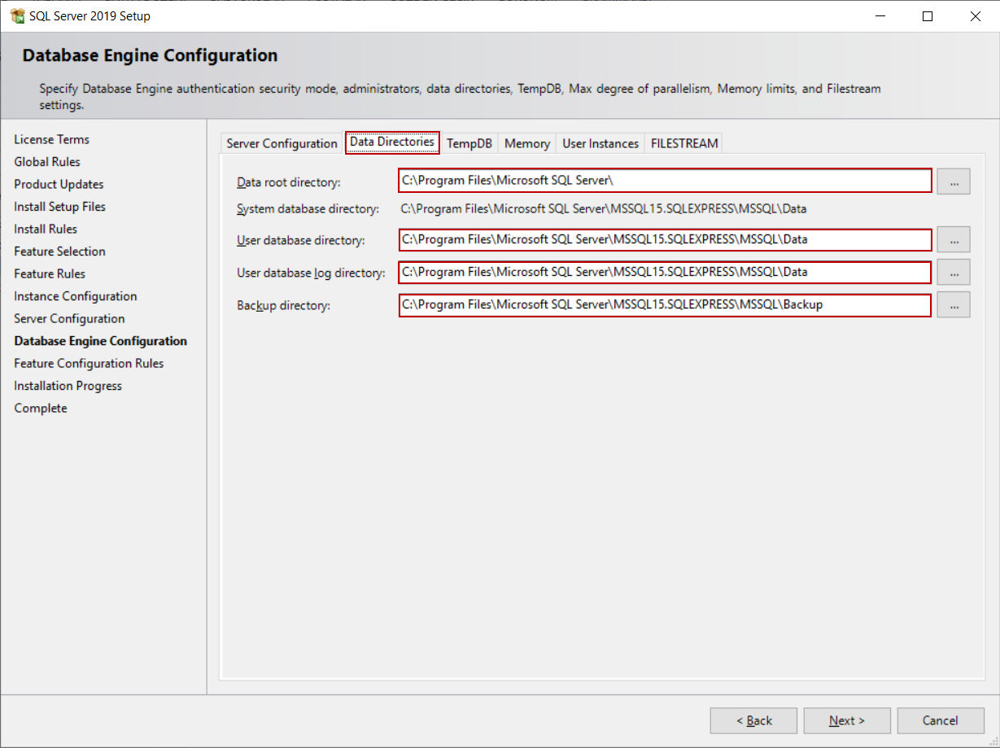

In the **TempDB** tab, we can set the number and size of the tempdb files. For this installation, we will not change these settings and click the **Next** button

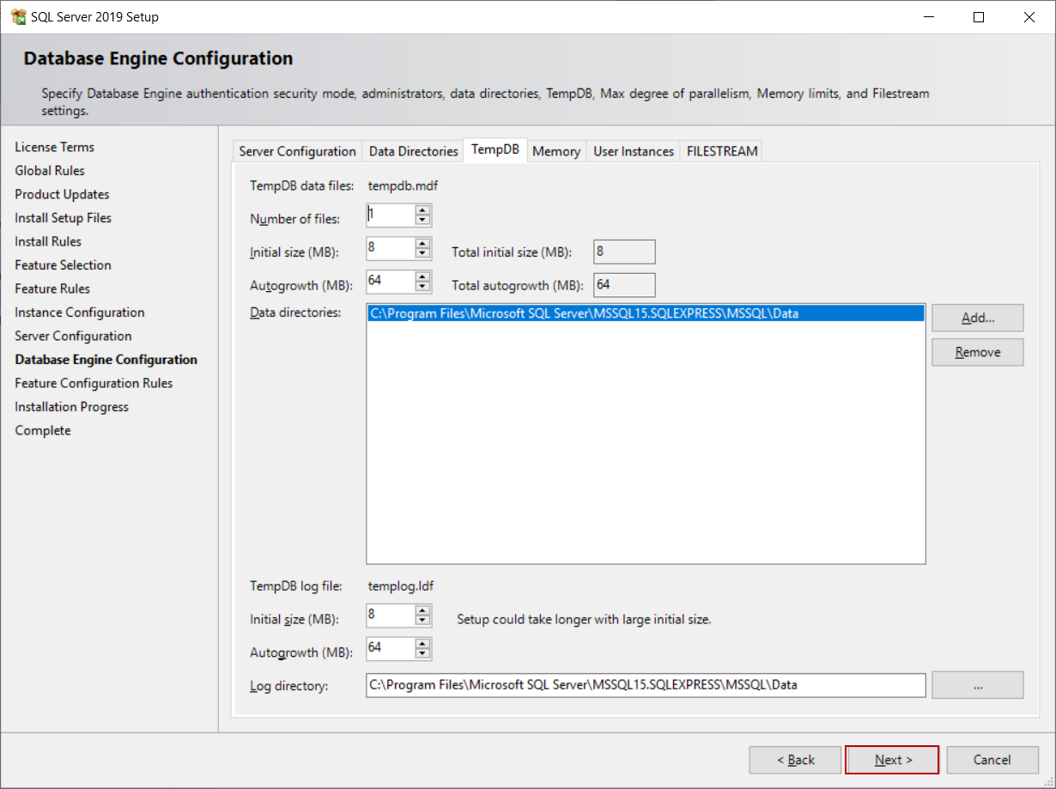

**Tip:**If you predict over workload on the TempDB database for your SQL Server, you can change the number of the tempdb files. Microsoft recommended the [following rule](https://docs.microsoft.com/en-us/sql/relational-databases/databases/tempdb-database?view=sql-server-ver15" \t "https://www.sqlshack.com/how-to-install-sql-server-express-edition/_blank) as a best practice:

“As a general rule, if the number of logical processors is less than or equal to eight, use the same number of data files as logical processors.”

In the **Installation Progress** screen, we can follow the progress of the installation

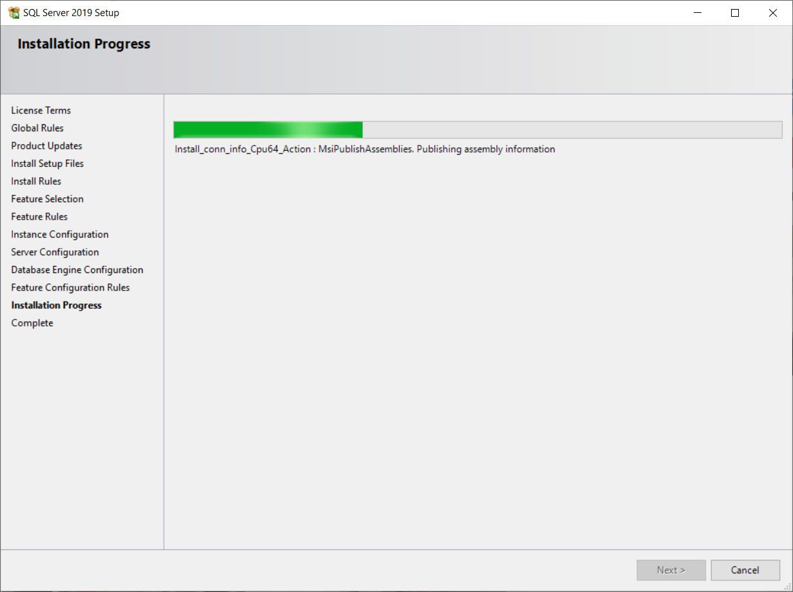

In the final step, the **Complete** screen meets us and it gives information about the result of the installation

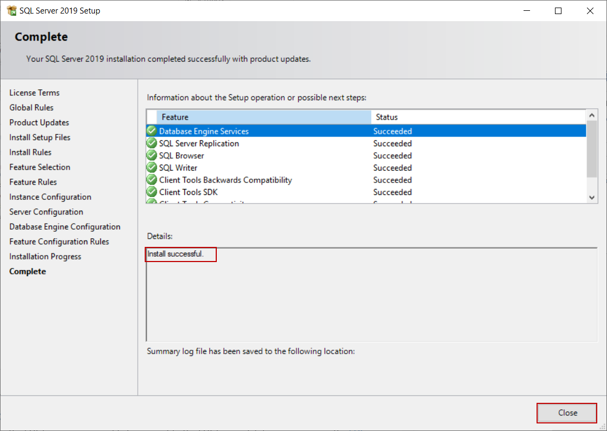

1. **SSMS Setup**

## Install Microsoft SQL Server Management Studio

**Step 1**

To install SQL Server Management Studio 2019, you need to download it from this [link](https://docs.microsoft.com/en-us/sql/ssms/download-sql-server-management-studio-ssms?view=sql-server-ver15" \t "https://www.c-sharpcorner.com/article/how-to-install-sql-server-management-studio-2019/_blank).

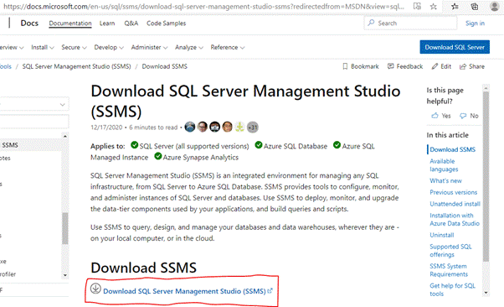

**Step 2**

Click the "Download" button for downloading the SSMS 2019 executable file on the downloaded path.

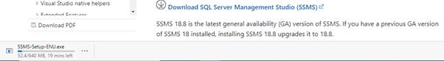

**Step 3**

Open your system download path and find the .exe file. SSMS-Setup-ENU.exe

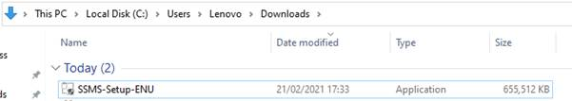

**Step 4**

Double-click the .exe file SSMS-Setup-ENU.exe to starting installing. The installation process of SMSS is straightforward which you just need to follow the screen sequence.



**Step 5**

After double-clicking, the system will ask the permission: “Do you want to allow the following to make a change to this computer? Click yes to continue installing the SQL Server Management Studio 2019, or...

Click “Yes” on any security prompt.

**Step 6**

The installation window will be open after giving permission to install. Click the Install button.

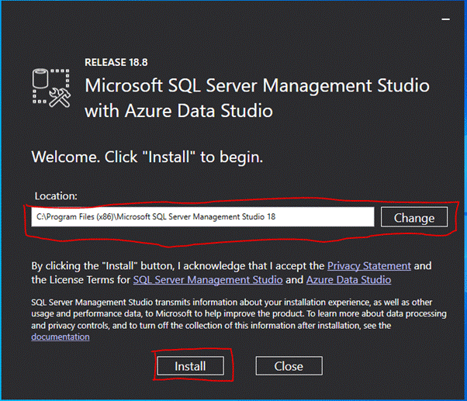

**Step 7**

After loading packages progress bar will be shown. One is Package Progress and Overall Progress. Wait for few minutes while the installer sets up the software.

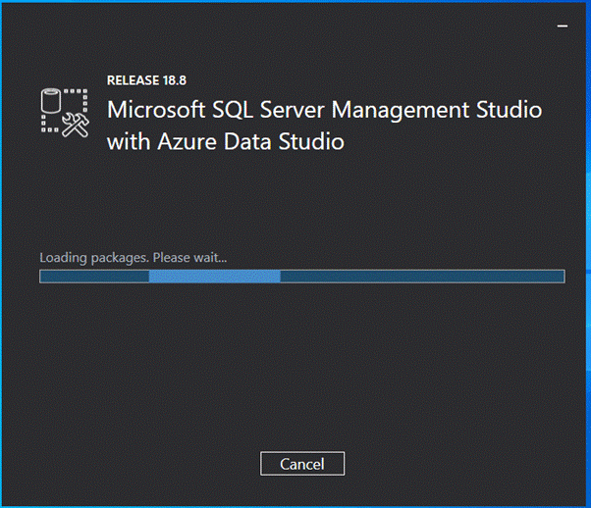

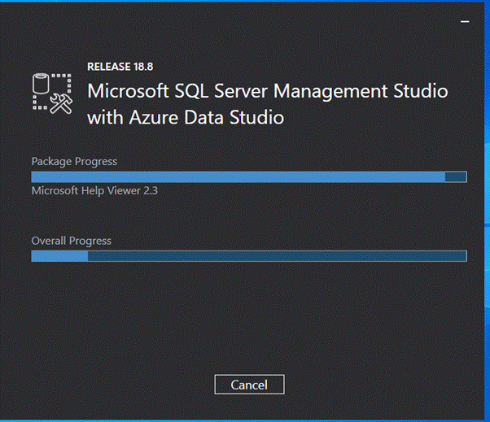

**Step 8**

Installation completed. After completing the installation restart your computer for a complete setup.

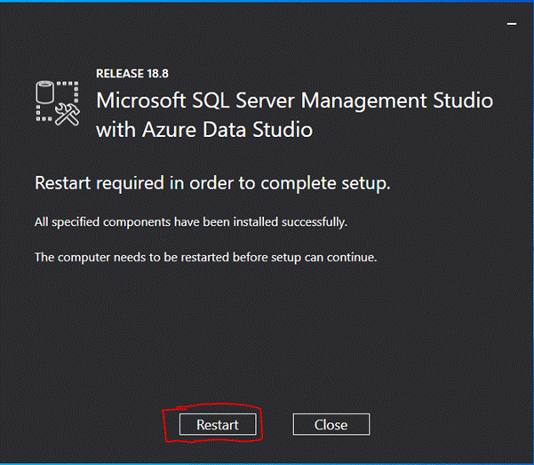

**Step 9**

Go to all programs in your systems, we can see two folders one is Microsoft SQL Server 2019 and another one is Microsoft SQL Server Tool 2018. Under Microsoft SQL Server Tools 18 you can see the Microsoft SQL Server Management Studio 18.

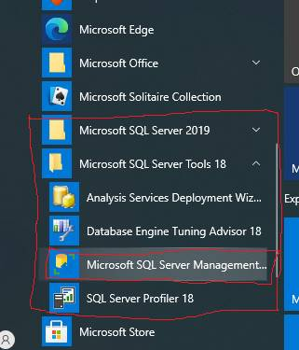

**Step 10**

Double-click on SQL Server Management Studio 18 and it will open looks like the below screenshot. The first time opening it will take a few minutes.

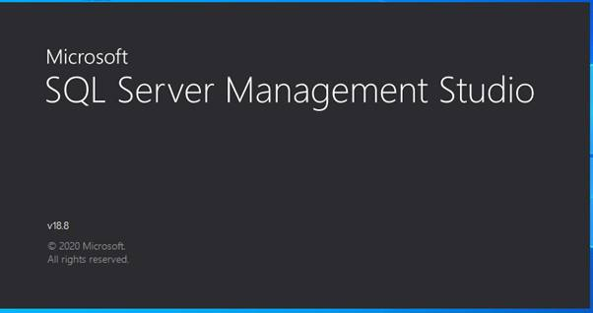

After opening SQL Server Management Studio 2018, we can see that it looks like the below screenshot.

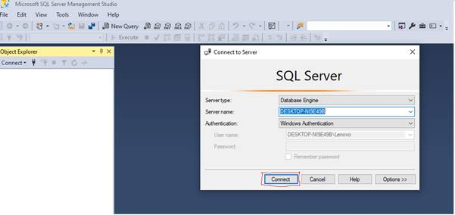

Now we can connect to the server and use SQL Server Management Studio 2019.